
CENTRAL UNIVERSITY SIERRA LEONE

PROJECT 2 PROPOSAL
GROUP ONE (1).

GROUP MEMBERS

INTRODUCTION:
The global restaurant industry is fundamental to urban social infrastructure, evolving rapidly alongside advancements in digital commerce and changing consumer expectations for convenience and speed. Dining has transitioned from a simple service to a technology driven experience, yet while major franchises have successfully integrated sophisticated digital ecosystems, a significant number of restaurants, particularly independent establishments continue to rely on traditional, manual operational models. This reliance is often due to high implementation costs, technical barriers, and a lack of customized solutions that cater to the specific dynamic needs of restaurant management.
These conventional systems are frequently plagued by operational inefficiencies, such as unmanaged queues during peak hours, order inaccuracies due to miscommunication, and delayed service delivery. Such bottlenecks not only hinder scalability but also diminish the overall customer dining experience in an era where digital presence is paramount. In response to these challenges, this project proposes the development of SwiftBite, a comprehensive web-based food ordering platform designed to modernize restaurant operations. SwiftBite aims to digitize the core workflow from menu presentation and order placement to payment processing and delivery management. By bridging the gap between culinary service and modern technology, the system seeks to enhance customer satisfaction, streamline restaurant logistics, and ensure a seamless, efficient, and error-free ordering process for both patrons and restaurant staff.

BACKGROUND:
The food industry urgently needs better solutions because traditional methods are slow, often lead to errors, and lack reliable online payment options. This inadequacy creates a significant gap in the market, making it hard for customers to order efficiently and difficult for businesses to manage their money and staff properly.
SwiftBite is a web application built to solve this core problem. It functions as a centralized ordering platform that introduces necessary speed, automation, and security to the entire food service process, ensuring a modern, streamlined experience for both customers and partnering restaurants.

PROBLEM STATEMENT:
Despite the critical role of the food service sector in the modern economy, the traditional operational methods employed by many restaurants suffer from significant deficiencies that compromise service delivery and financial management. Reliance on manual order processing, the absence of secure digital payment infrastructures, and the high propensity for human error have frequently led to transaction failures, operational bottlenecks, and administrative inconsistencies. These inefficiencies not only degrade the customer experience but also impede the ability of businesses to effectively manage revenue streams and personnel.
In addressing these systemic challenges, SwiftBite is designed as a centralized web application aimed at resolving these core vulnerabilities. By introducing necessary automation, speed, and security into the ordering lifecycle, the platform ensures a modernized, streamlined, and transparent experience for both customers and partnering restaurants.

LITERATURE REVIEW:

OVERVIEW OF FOOD DELIVERY SERVICES:
The digitization of food delivery services has been increasingly adopted due to the drawbacks of traditional ordering methods, which include long waiting times, frequent order inaccuracies, and inefficient payment processing.
EXISTING PLATFORMS AND INNOVATIONS:
Send Me SL introduced a mobile-based logistics platform that successfully connected customers with local vendors across Freetown. Their operations demonstrate the viability of digital delivery systems in reducing service delays and overcoming infrastructure challenges in the local market.
ARCHITECTURAL AND FUNCTIONAL CHALLENGES:
Hassan et al. (2018) underlined the importance of robust system architecture in achieving reliable order accuracy and real-time data synchronization. These principles directly inform this study’s approach to secure payment integration and modular backend design.
SECURITY AND USABILITY CONSIDERATIONS:
Laudon and Traver (2021) emphasized that robust encryption and secure authentication mechanisms are fundamental to preventing data breaches in e-commerce platforms. While SwiftBite prioritizes user convenience, this security-first mindset is strictly applied through features like encrypted payment gateways and role-based access control.
ADDRESSING RESEARCH GAPS:
Many existing food delivery platforms impose high operational costs and technical barriers, often alienating small, independent restaurants. SwiftBite fills a critical gap by providing a streamlined, accessible web solution, thereby extending the benefits of digital commerce to local eateries that lack the infrastructure for complex enterprise systems.
AIM
The aim of this study is to develop a modern, user-friendly web-based food ordering platform that improves the efficiency, speed, and accuracy of food service operations for local vendors. The system seeks to replace traditional manual ordering methods with a digital solution that provides real-time menu access, secure online payments, and order tracking, while enhancing customer satisfaction and supporting local businesses in transitioning to digital operations.

OBJECTIVES
The main objectives of this web application project are:
- To develop a simple and user-friendly platform for food ordering and delivery.
- To provide real-time access to menus, prices, and availability of meals.
- To allow secure and efficient online payment systems.
- To reduce long queues and improve order accuracy at the restaurants.
- To offer order tracking and delivery status updates to customers.
- To support local businesses in transitioning into digital operations.
- To ensure responsive design
- To enhance customer satisfaction

PRAOJECT SCOPE
1. Customer (End-User):
- Create an account, browse menus, order food.
- Make secure payments.
- Track order status and view history.

2. Restaurant Manager:
- Manage restaurant profile and menu.
- Accept/decline orders.
- Track sales and view order history.

3. Receptionist / Restaurant Staff:
- View and manage active orders.
- Update order statuses.
- Coordinate with kitchen staff.

4. Delivery Personnel:
- Access ready orders for pickup.
- Update delivery status.
- View customer and delivery details.

5. Platform Administrator (SwiftBite Admin):
- Manage all accounts and onboard restaurants.
- Oversee operations and handle disputes.
- Access system analytics and reporting.

RESEARCH QUESTIONS
- Our project will try to answer these questions:
- What is the most trusted and easiest payment method for online food orders in our area?
- What is the easiest way for a customer to compare different restaurant menus on one website?
- How can a simple website help small restaurants attract new customers?

LIMITATION
- No offline Support
- Biometric authentication not included
- No mobile App development

METHODOLOGY:
Data Collection Methods: To evaluate the effectiveness of SwiftBite, a mixed-methods approach will be used, combining both quantitative and qualitative data to measure system performance and user satisfaction.
Quantitative Data: Survey questionnaires using Likert-scale to rate ease of use, order accuracy, payment security, and delivery timeliness. System usage analytics including number of orders placed, peak usage times, payment success rates, and error logs.
Qualitative Data: Short interviews and feedback forms from customers, restaurant staff, and delivery personnel to gather opinions, challenges, and improvement suggestions. Focus group discussions involving users, restaurant managers, and technical support teams to explore user experience and system usability in depth.

TOOLS AND TECHNOLOGIES
- Languages: JavaScript
- Frontend Tools: React Js, Css and Html (Ejs)
- Backend Tools: Node Js with Express Js.
- Database: Postgre SQL
- Key Integrations: Stripe, Monime or PayPal API (Secure Payment), Google Maps API or Mapbox (Location Services)
- Design: Figma/Canva/.
- IDE: Vs Code.
- Project Management: GitHub (Render) Projects, Google Doc.

SECURITY FEATURES:
FEATURE | IMPLEMENTATION
Data Encryption and Privacy | Utilizing HTTPS (SSL/TLS) for all data transmission and using hashing and encryption for stored data (passwords, address, location). Payment integration uses Tokenization
User Authentication and Authorization | Enforcing a Strong Password Policy and implementing Role-Based Access Control (RBAC) to strictly limit feature access based on user role (Customer, Manager, Receptionist, Platform Manager)
Feature-Specific Security Measures | Employing Input Validation to prevent attacks (SQL/XSS) and ensuring Daily Payment Log Integrity via read-only access for earning records, preventing manual alteration.

Team roles and responsibilities:
- Team Lead: Coordination, progress tracking, report consolidation
- UI Developer: Interface design
- Backend Developer: Core logic, database interaction, encryption
- Tester & Documentation Lead: Functional testing, evaluation, user guide preparation
EVALUATION PLAN:
- Unit testing of each module.
- System testing for functionality and usability.
- User feedback from test users (Restaurants Staff and Customers).
- Performance evaluation (speed, load handling).

PROJECT TIMELINE:

ACTIVITIES | DURATION
Project planning and requirement gathering | 1 week
System Analysis and Design | 1 week
Database Development and Setup | 2 weeks
Core Functionality  Development | 2 weeks
Result Tallying and Reporting | 2 weeks
System Testing and Debugging | 1 week
System Deployment and Documentation | 1 week

REFERENCE:
- Chavan, V., Jadhav, P., Korade, S., & Teli, P. (2015). Implementing customizable online food ordering system using web based application. International Journal of Innovative Science, Engineering & Technology, 2(4), 722-727.
- Kimes, S. E. (2011). The current state of online food ordering. Cornell Hospitality Reports, 11(17), 6-18.
- Laudon, K. C., & Traver, C. G. (2021). E-Commerce 2021-2022: Business, Technology, Society (16th ed.). Pearson.
- Pressman, R. S., & Maxim, B. R. (2019). Software Engineering: A Practitioner's Approach (9th ed.). McGraw-Hill Education.
- Rayport, J. F., & Jaworski, B. J. (2004). Introduction to E-Commerce. McGraw-Hill/Irwin.
- Shin, S., Lee, M., & Odom, B. (2019). The effect of data security and legal protection on e-commerce adoption. Journal of Computer Information Systems, 59(2), 1-10.
- Yeo, V. C. S., Goh, S. K., & Rezaei, S. (2017). Consumer experiences, attitude and behavioral intention toward online food delivery (OFD) services. Journal of Retailing and Consumer Services, 35, 150-162.
Zhu, L. (2016). Security architecture for web-based information systems. International Journal of Computer Applications, 148(9), 23-28

Feasibility Study Final Document: SwiftBite – Web-Based Food Ordering System.

1. Title Slide
Project Title: SwiftBite – A Web-Based Food Ordering and Delivery System
Group: BITCOM Group 1 (Year 3)
Institution: Central University, Technical Sciences Department
Course: Project Two
Supervisor: Mr. Abdul Medizo Kamara and Team
Date: [19th January 2026]
2. Introduction / Background of the Study
The food service industry is rapidly evolving, driven by increasing demands for speed, convenience, and digital integration. However, many local vendors still rely on traditional manual methods, leading to inefficiencies such as long queues, order inaccuracies, and lack of secure digital payment options. SwiftBite is proposed as a centralized web-based platform designed to modernize food ordering processes, enhance customer experience, and support local businesses in their digital transition. This feasibility study assesses the viability of developing and deploying SwiftBite from technical, financial, operational, and legal perspectives.

3. Description of the Idea / Project Concept
SwiftBite is a full-stack web application that enables customers to browse restaurant menus, place orders online, make secure payments, and track deliveries in real-time. The system also provides vendors with an intuitive dashboard to manage menus, orders, and customer interactions. Built using modern web technologies, SwiftBite aims to bridge the digital gap for small and medium-sized eateries, offering them an affordable and scalable online presence.

4. Problem Identification
- Manual order processing leads to delays and errors.
- Lack of digital payment systems limits transaction security and convenience.
- Poor order tracking reduces transparency and customer trust.
- Inefficient communication between customers and vendors during peak hours.
- High operational costs for small restaurants to adopt enterprise-level solutions.

5. Objectives of the Feasibility Study
- To evaluate the technical feasibility of developing SwiftBite using modern web technologies.
- To assess the financial viability of the project within a limited budget.
- To determine the operational sustainability of the system in real-world scenarios.
- To identify legal and ethical considerations related to data security and user privacy.
- To propose a realistic implementation timeline and risk mitigation strategies.

6. Justification / Rationale for the Study
The shift toward digital food ordering is inevitable, yet many local vendors lack the resources to develop or adopt such systems. SwiftBite addresses this gap by providing a low-cost, scalable, and user-friendly platform that enhances operational efficiency, improves customer satisfaction, and promotes digital inclusion. This study ensures that the project is practical, sustainable, and aligned with both academic and industry standards.

7. Target Users / Beneficiaries
- Customers: Students, urban residents, and busy professionals seeking convenient food ordering.
- Vendors: Small and medium-sized restaurants aiming to digitize their operations.
- Administrators: System managers responsible for oversight and support.
- Delivery Personnel: Individuals involved in the logistics and fulfillment process.

8. Technical Feasibility
- Frontend: React.js or EJS with CSS (Bootstrap/Tailwind)
- Backend: Node.js with Express.js
- Database: PostgreSQL for secure and structured data storage
- Version Control: Git & GitHub
- Architecture: Client–server model with RESTful APIs
- Team Skills: Foundational knowledge in JavaScript, web development, and databases
- Hardware: Standard laptops (Intel i5/Ryzen 3, 8GB RAM, 256GB SSD)
- Software: Free and open-source tools (VS Code, Node.js, PostgreSQL)

9. Economic / Financial Feasibility
- Total Estimated Cost: NLe 1,500
  - Internet Data: NLe 500
  - Documentation/Printing: NLe 200
  - Miscellaneous: NLe 800
- No licensing costs (all tools are open-source)
- Reduces operational costs for vendors by automating order processing
- Financially sustainable for academic deployment and potential scaling

10. Operational Feasibility
- User-friendly interface for both customers and vendors
- Scalable architecture to handle increasing users and orders
- Training and support planned for vendors and administrators
- Integration with existing restaurant workflows without major disruption
- Real-time order tracking and notifications to enhance transparency

11. Legal and Ethical Considerations
- Data Protection: Implementation of secure authentication, password hashing, and encrypted transactions
- Privacy Compliance: Adherence to user data privacy standards
- Role-Based Access Control: Differentiated permissions for customers, vendors, and admins
- Ethical Use: Transparent pricing, fair vendor terms, and responsible data handling

12. Potential Challenges and Risks
- Technical Risks: Integration issues with payment gateways, database scalability, cross-browser compatibility
- Operational Risks: User adoption reluctance, vendor onboarding delays, network dependency
- Financial Risks: Unforeseen costs for hosting, maintenance, or third-party services
- Legal Risks: Data breaches, non-compliance with local e-commerce regulations
- Mitigation Strategies: Regular testing, user training, phased rollout, and legal consultation

13. Conclusion
The SwiftBite project is technically feasible, financially viable, and operationally sound. It addresses a clear market need, leverages accessible technologies, and aligns with academic learning outcomes. With proper planning and execution, SwiftBite has the potential to significantly improve the food ordering experience for customers and vendors alike, while serving as a practical case study in full-stack web development and project management.

14. Recommendations
- Prototype Development: Begin with a minimum viable product (MVP) focusing on core features.
- User Testing: Conduct alpha and beta testing with real users to gather feedback.
- Security Audit: Perform regular security assessments, especially for payment and data modules.
- Vendor Partnerships: Collaborate with local restaurants early to ensure platform relevance.
- Documentation: Maintain detailed technical and user documentation throughout the project lifecycle.
- Scalability Planning: Design the system with future enhancements in mind (e.g., mobile app, AI recommendations).

DESIGN PHASE Final Document: SwiftBite – Web-Based Food Ordering System.
Project Title: SwiftBite – A Web-Based Food Ordering and Delivery System
Group: BITCOM Group 1 (Year 3)
Institution: Central University, Technical Sciences Department
Course: Project Two
Supervisor: Mr. Abdul Medizo Kamara and Team
TABLE OF CONTENTS

- Project Overview ......................................................................................... 3
- What is UML Diagram ................................................................................... 4
- Use Case Diagram ........................................................................................ 5
- Sequence Diagram ........................................................................................ 6
- Activity Diagram ........................................................................................... 8
- Entity Relationship Diagram (ERD) .............................................................. 9
- Class Diagram .............................................................................................. 10
- Dataflow Diagram (Level 0, 1, and 2) ............................................................ 11
- Conclusion .................................................................................................... 12
- References .................................................................................................... 13

1. PROJECT OVERVIEW
The SwiftBite Food Ordering Service is a digital solution designed to streamline interactions between customers and food service providers. The system automates menu browsing, ordering, and payment processes, ensuring a seamless experience for users while providing robust management tools for restaurant administrators and staff. This documentation details the architectural and behavioral models forming the system's blueprint.

2. WHAT IS UML DIAGRAM

Unified Modeling Language (UML): UML is a standardized visual language used to specify, visualize, construct, and document the design of software systems. It provides a set of diagram types (such as use case, class, sequence, and activity diagrams) to model both the static structure and dynamic behavior of a system.

Why UML is important for building a system:

- ✓ It helps communicate complex system designs clearly among stakeholders (developers, architects, and clients).
- ✓ It enables early detection of design flaws through visualization.
- ✓ It serves as blueprint documentation that guides development, testing, and maintenance.
- ✓ It supports object-oriented design principles, making systems modular, reusable, and easier to maintain.

3. USE CASE DIAGRAM

A Use Case Diagram is used to capture, gather, and visualize the functional requirements of a system. It includes both internal and external actors and the system itself, showing what the system should do from the user's perspective.

Figure 1: Showing Use Case Diagram for SwiftBite Food Ordering Service 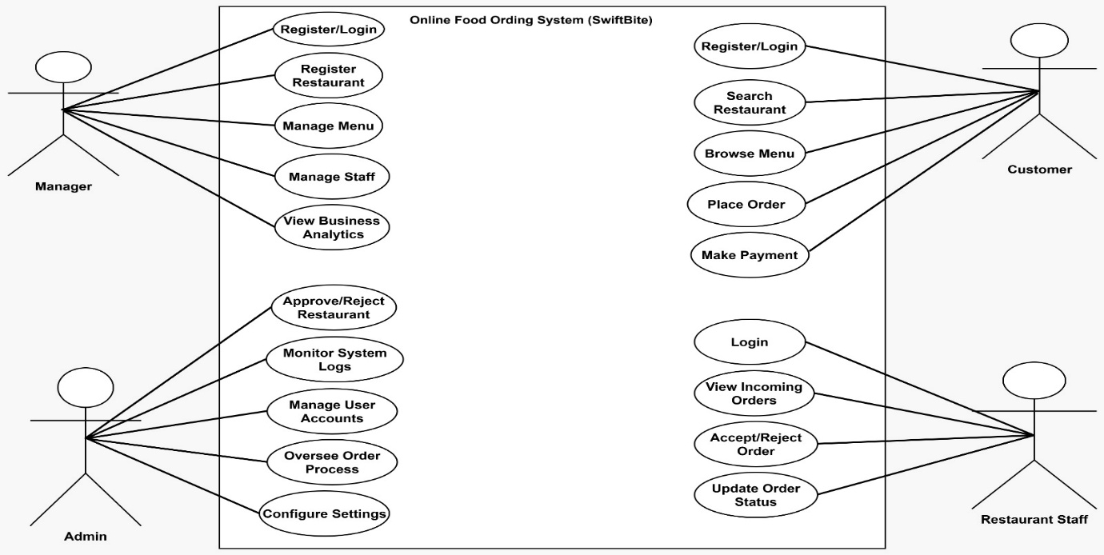

Description of Actors:
- Customer: Browses the digital menu, places orders, and makes payments.
- Admin: Oversees system settings, manages user accounts, and reviews analytics.
- Manager: Handles menu updates and monitors daily sales reports.
- Staff: Processes incoming orders and updates food preparation status.

4. SEQUENCE DIAGRAM

It describes the types of interactions among different elements in the model and the time ordering of messages between objects in specific requirements. It also presents the dynamic behavior of a system.

Figure 2: Showing Admin Sequence Diagram 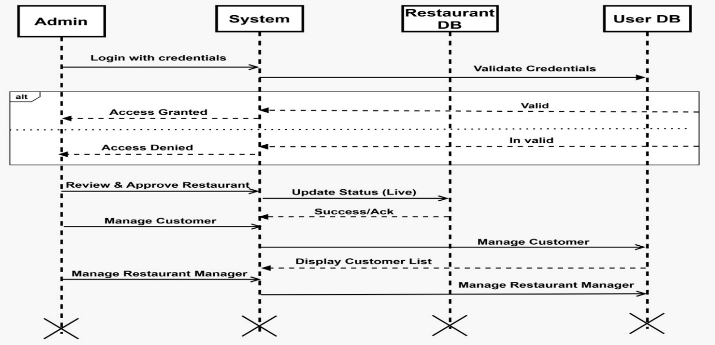

Figure 3: Showing Manager Sequence Diagram 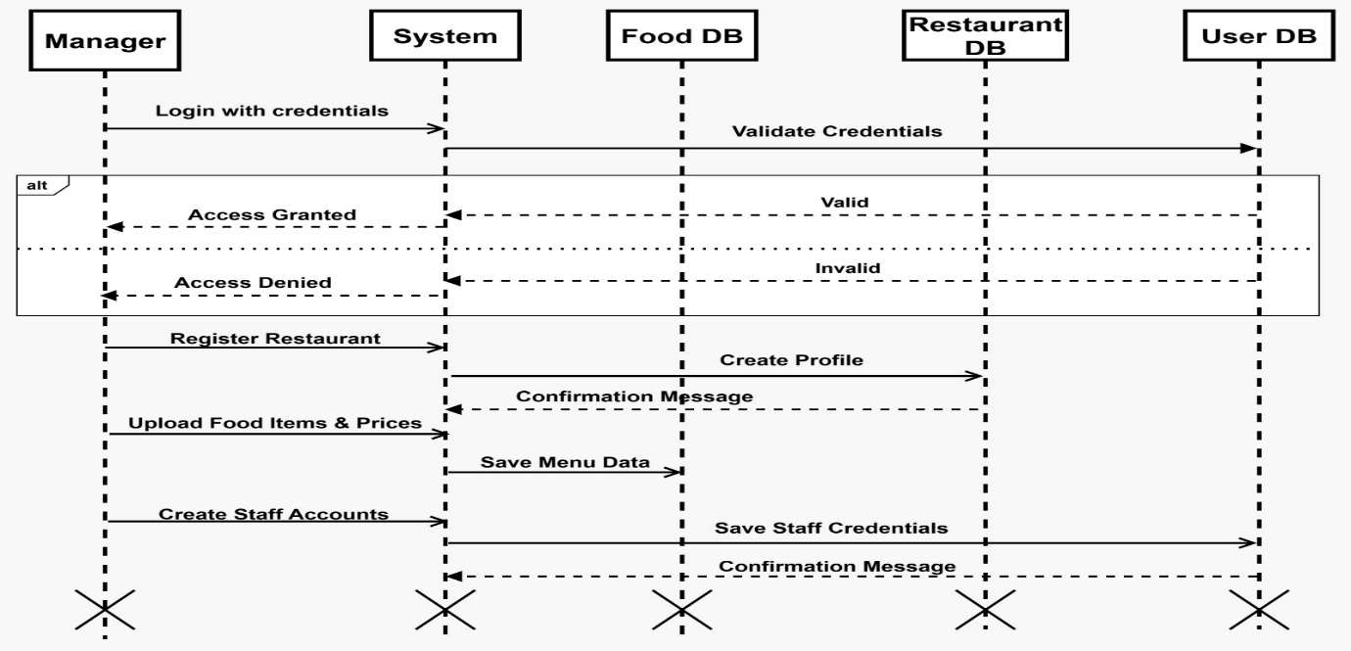

Figure 4: Showing Staff Sequence Diagram 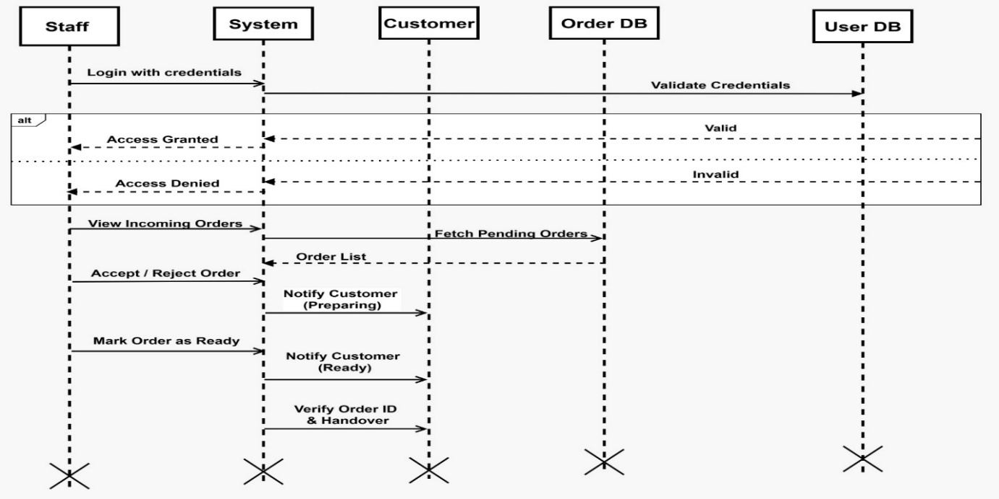

Figure 5: Showing Customer Sequence Diagram 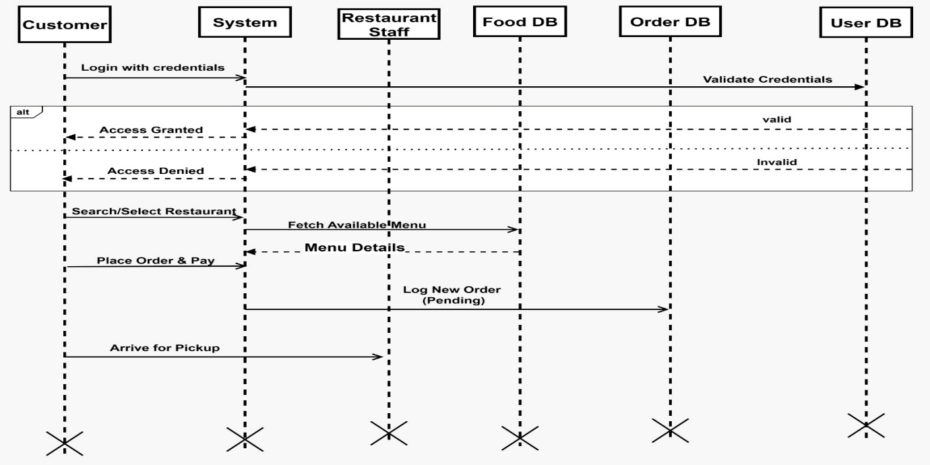

5. ACTIVITY DIAGRAM

An activity diagram is a type of UML diagram that represents the workflow of information from one activity to another within a system.

Figure 6: Showing Admin Activity Diagram 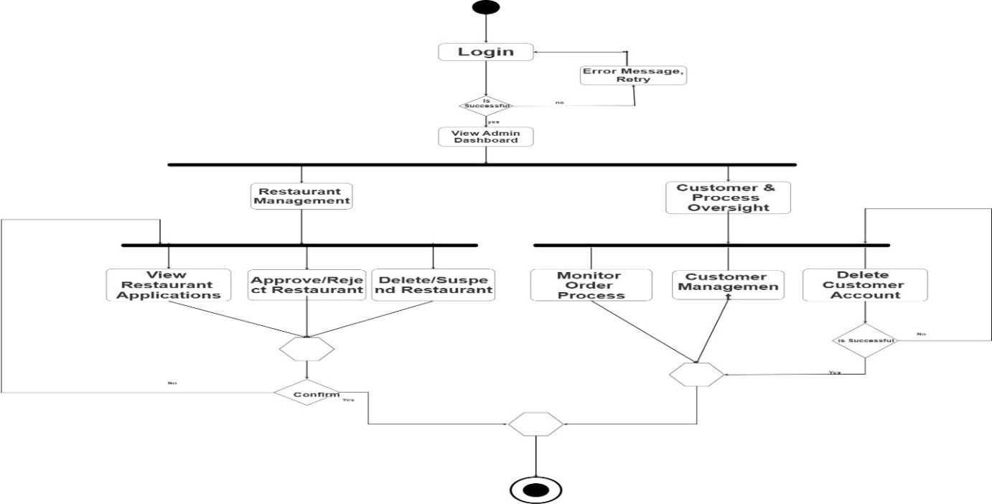

Figure 7: Showing Manager Activity Diagram 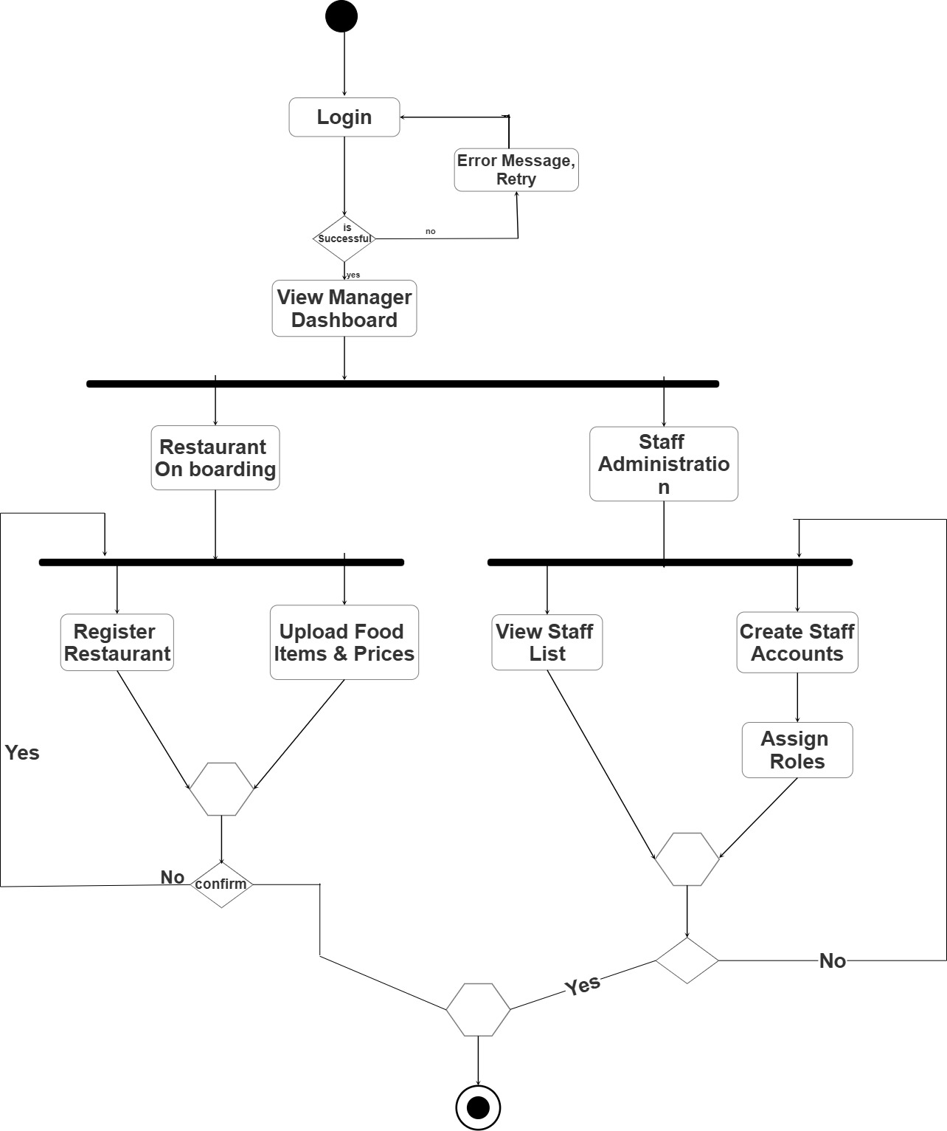

6. ENTITY RELATIONSHIP DIAGRAM (ERD)

The ERD provides a visual representation of the system's database structure, detailing how data entities relate to one another.

Figure 8: Showing Entity Relationship Diagram for SwiftBite 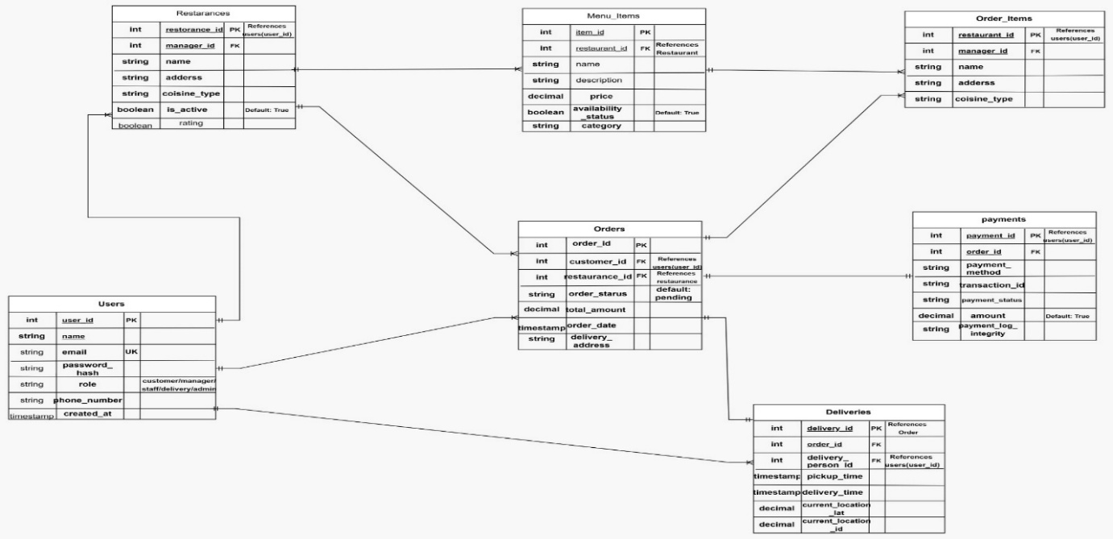

7. CLASS DIAGRAM

The Class Diagram shows the system's static structure by illustrating the classes, their attributes, operations, and the relationships among objects.

Figure 9: Showing Class Diagram for SwiftBite 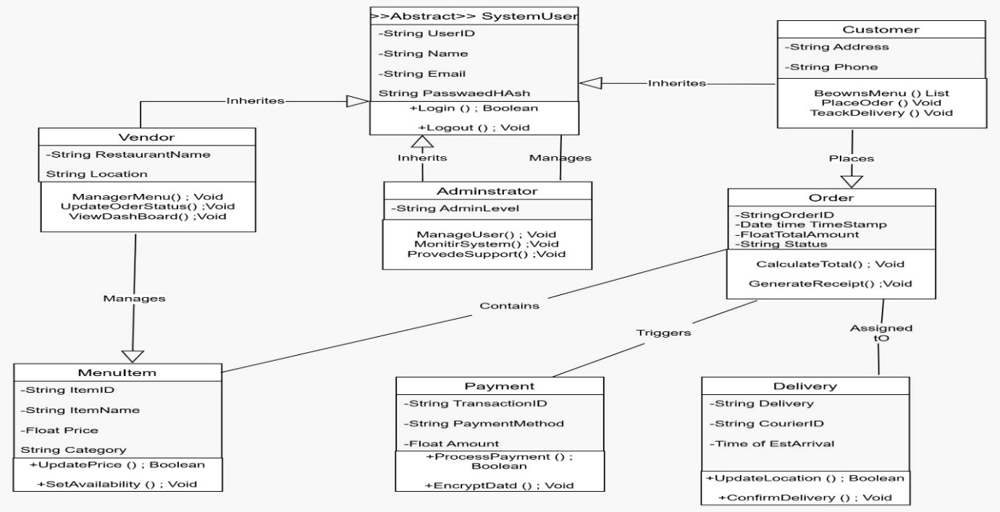

8. DATAFLOW DIAGRAM (DFD)

Dataflow diagrams model the flow of information through the system, identifying processes, data stores, and external entities.

Figure 10: Showing Dataflow Diagram Level 0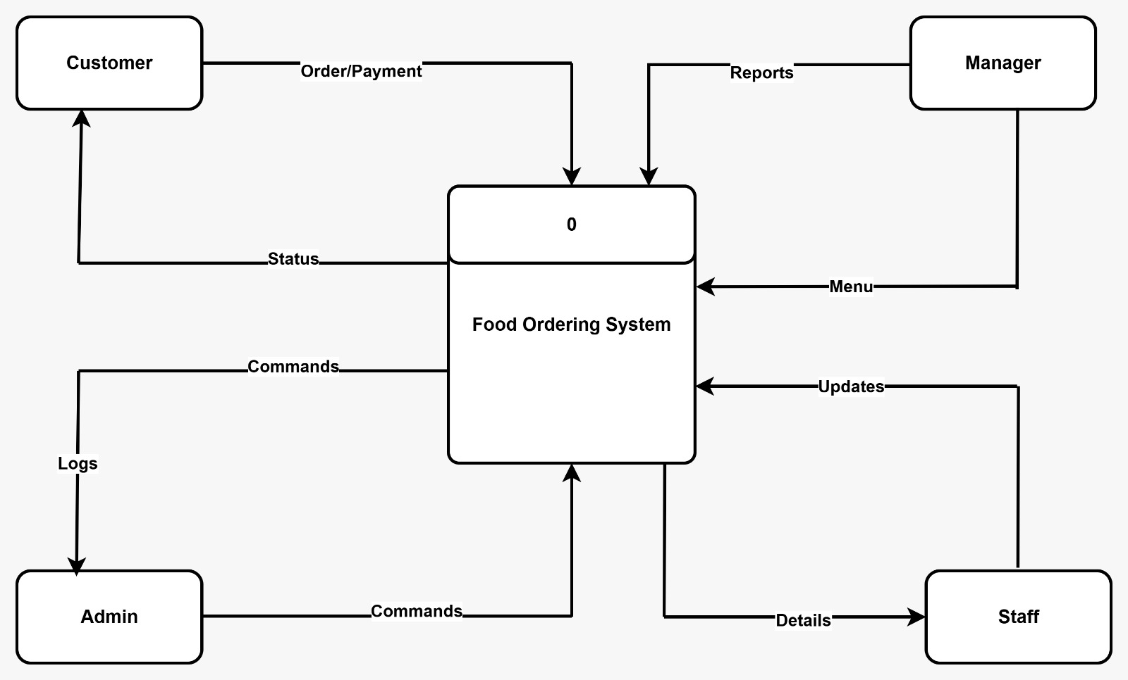

Figure 11: Showing Dataflow Diagram Level 1 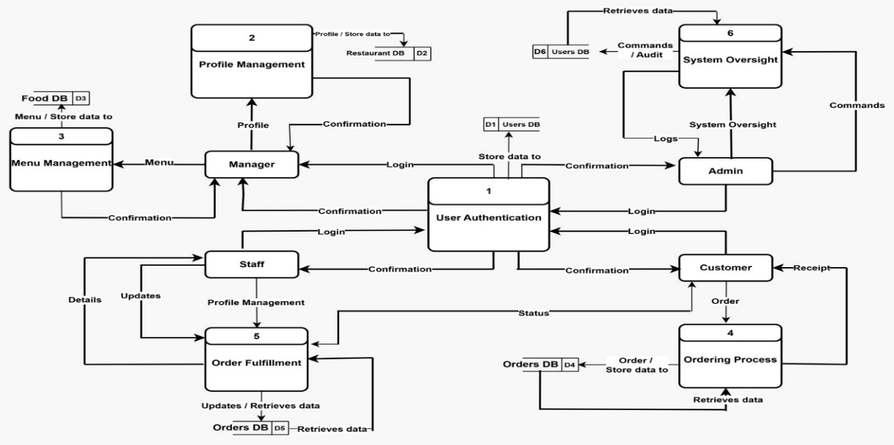

Figure 12: Showing Dataflow Diagram Level 2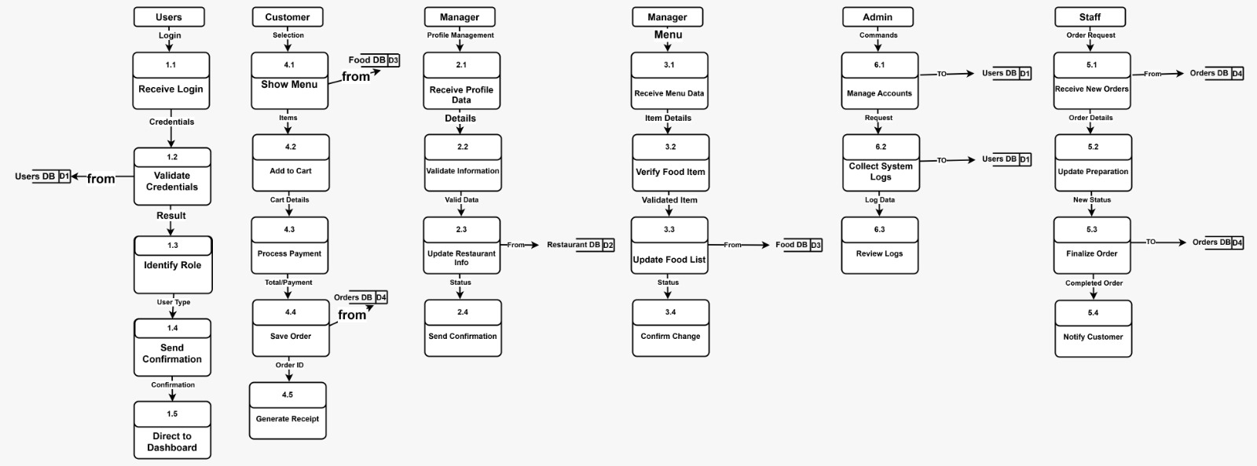

9. CONCLUSION

The design phase for SwiftBite Food Ordering Service has established a comprehensive technical blueprint. By utilizing UML diagrams and Dataflow models, we have mapped user interactions and the internal system architecture to guide the development phase effectively.

10. REFERENCES

- Central University. (2025). Capstone Project 1 Design Phase Reference Document.
- SwiftBite Development Team. (2025). Design Phase Presentation Slides.

Implementation Phase : SwiftBite – Web-Based Food Ordering System.
ADMIN PAGE

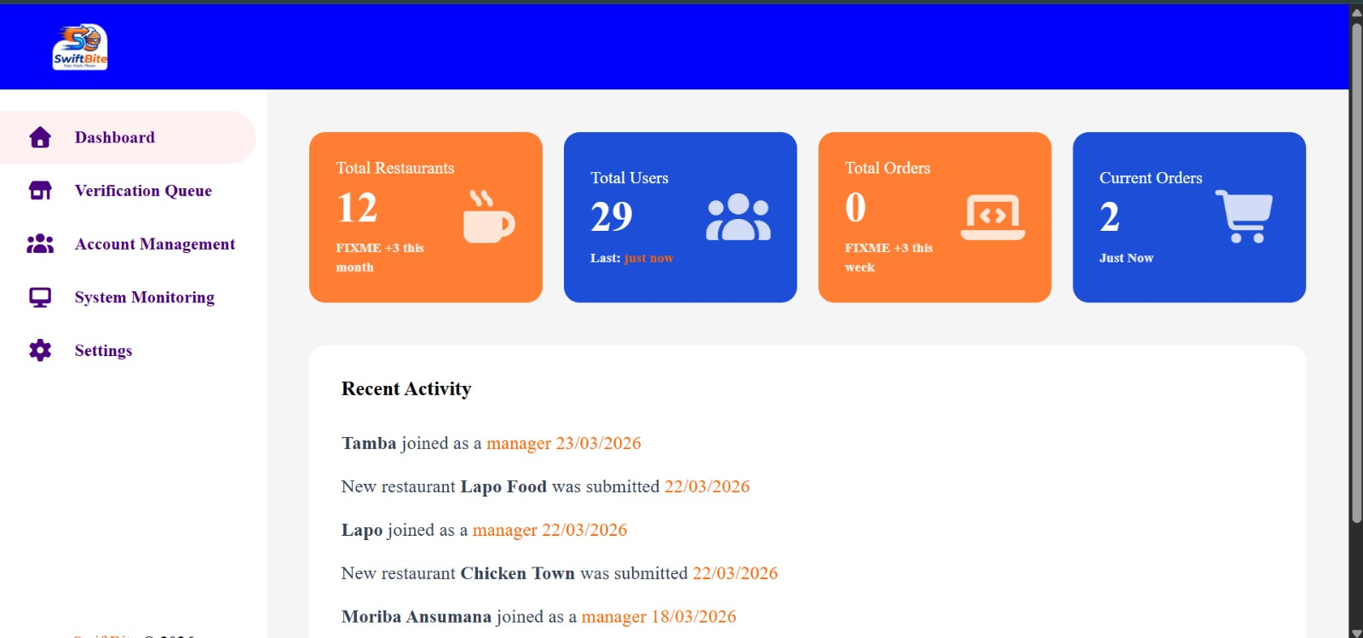

Implementation code
app.get("/admin/dashboard", async (req, res) => {
if (req.isAuthenticated() && req.user.role?.toLowerCase() === "admin") {
try {
const userRes = await db.query("SELECT COUNT(*) FROM users");
const name = await db.query("SELECT * FROM users WHERE role = 'admin'");
console.log("USER: ", name.rows[0].full_name);
const orders = await db.query(
"SELECT COUNT(*) FROM orders WHERE status = 'complete'",
);
console.log("thefkljdlf", orders);
const restRes = await db.query(
"SELECT COUNT(*) FROM restaurants WHERE status = 'approved'",
);

const activityRes = await db.query(`
(SELECT full_name AS actor, role, 'user_signup' AS type, created_at
FROM users)
UNION ALL
(SELECT name AS actor, 'Manager' AS role, 'restaurant_added' AS type, created_at
FROM restaurants)
ORDER BY created_at DESC
LIMIT 5
`);

res.render("admin/home.ejs", {
currentPage: "dashboard",
user: req.user,
stats: {
users: userRes.rows[0].count,
name: name.rows[0].full_name,
restaurants: restRes.rows[0].count,
orders: orders.rows[0].count,
},
activities: activityRes.rows,
});
} catch (err) {
console.error(err);
res.status(500).send("Internal Server Error");
}
} else {
res.redirect("/login");
}
});

Explaination
The Admin page shown in the screenshot is a dashboard for managing a restaurant/food‑ordering system called SwiftBite. Here’s a breakdown of its key sections:

1. Sidebar menu:
- Dashboard: The current view (home screen for admin).
- Verification Queue: A list of pending verifications (e.g., restaurant or user approvals).
- Account Management: Tools for handling user accounts and permissions.
- System Monitoring: Performance or health checks of the platform.
- Settings: General configuration options for the admin system.

2. Top statistic cards:
- Total Restaurants: 12 registered restaurants, with +3 added this month (FIXME note indicates a bug or update needed).
- Total Users: 29 users, with the last activity just now.
- Total Orders: 0 orders placed, expecting +3 this week (FIXME note suggests a tracking issue).
- Current Orders: 2 active orders at the moment.

3. Recent Activity panel: A log of the latest events in the system:
- Tamba joined as a manager on 23/03/2026.
- New restaurant Lapo Food was submitted on 22/03/2026.
- Lapo joined as a manager on 22/03/2026.
- New restaurant Chicken Town was submitted on 22/03/2026.
- Moriba Ansumana joined as a manager on 18/03/2026.

The page gives the admin an overview of the platform’s status and recent actions, enabling quick monitoring and management of restaurants, users, and orders.

SIGN IN PAGE AND SIGN UP PAGE

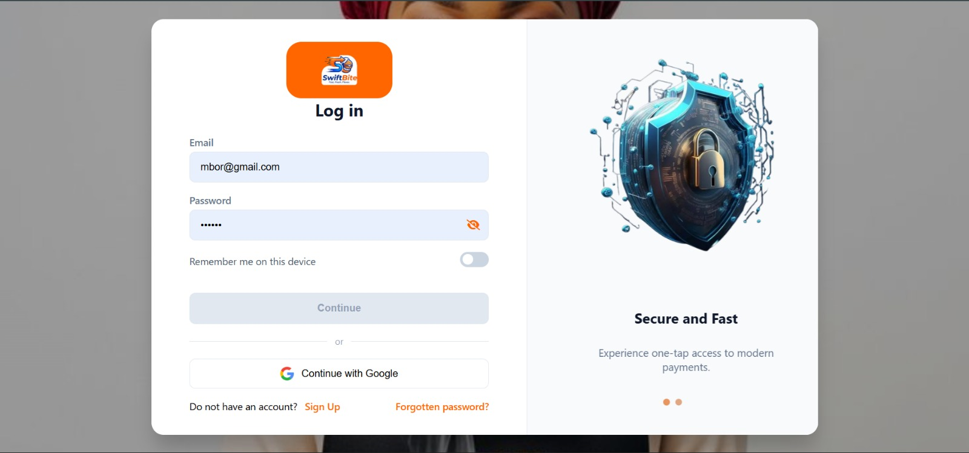

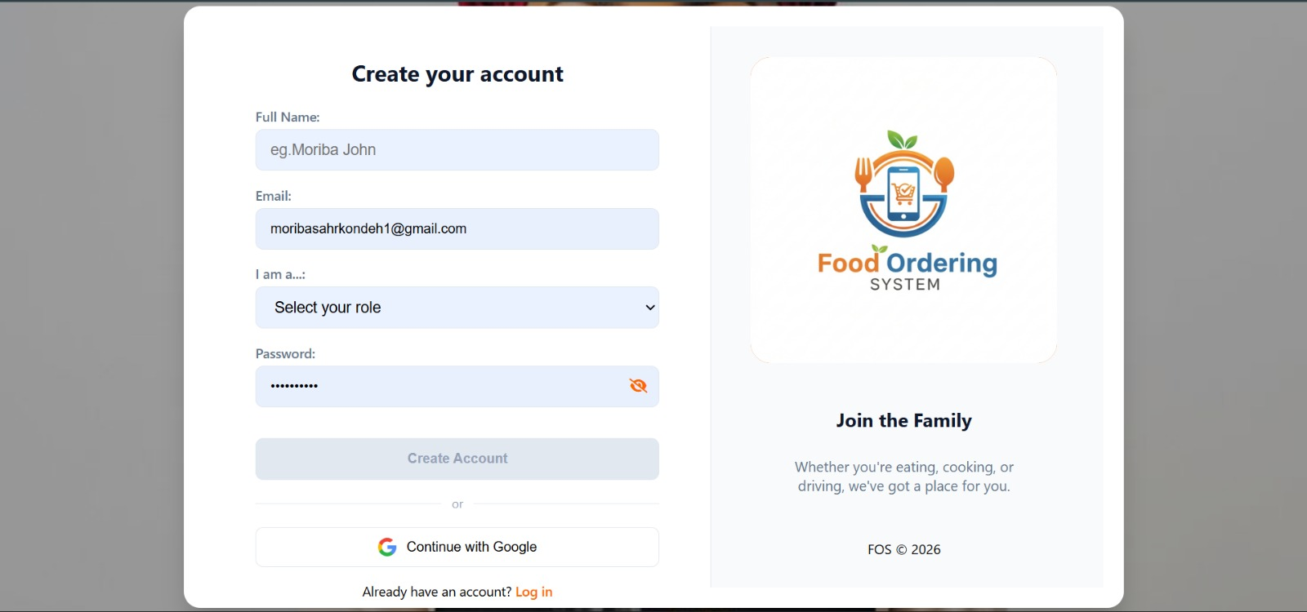
IMPLEMENTATION CODE FOR SIGN IN AND SIGN UP PAGE
app.post("/register", async (req, res) => {
const { fullname, email, password, role } = req.body;
console.log(fullname, email, password, role);

try {
const result = await db.query("SELECT * FROM users WHERE email = $1", [
email,
]);

if (result.rows.length > 0) {
res.render("index.ejs", {
message: "The user you want to register already exist.",
});
} else {
bcrypt.hash(password, saltRound, async (err, hash) => {
if (err) {
res.status(500).send("Error creating account");
} else {
try {
const newUser = await db.query(
"INSERT INTO users(full_name, email, password_hash, role) VALUES($1, $2, $3, $4) RETURNING *",
[fullname, email, hash, role],
);

const countRes = await db.query("SELECT COUNT(*) FROM users");
const totalUsers = countRes.rows[0].count;

io.emit("update-user-count", {
total: totalUsers,
name: fullname,
});

const user = newUser.rows[0];
console.log(user);

req.login(user, (err) => {
if (err) {
res.redirect("/login");
} else {
res.redirect("/dashboard");
}
});
} catch (dbErr) {
res.status(500).send("Error creating account");
}
}
});
}
} catch (err) {
res.status(500).send("Error processing request");
}
});

passport.use(
"local",
new Strategy({ usernameField: "email" }, async function verify(
email,
password,
cb,
) {
try {
const query = `
SELECT id::TEXT, email, password_hash, role, 'users' AS table_type FROM users WHERE email = $1
UNION ALL
SELECT id::TEXT, email, password_hash, role, 'staff' AS table_type FROM staff WHERE email = $1
LIMIT 1
`;
const result = await db.query(query, [email]);
const user = result.rows[0];

if (!user) return cb(null, false, { message: "Account not found." });

bcrypt.compare(password, user.password_hash, (err, valid) => {
if (err) return cb(err);
if (valid) {
user.tableType = user.table_type;
return cb(null, user);
} else {
return cb(null, false, { message: "Incorrect password." });
}
});
} catch (err) {
return cb(err);
}
}),
);

passport.use(
"google",
new GoogleStrategy(
{
clientID: process.env.CLIENTID,
clientSecret: process.env.CLIENT_SECRET,
callbackURL: "http://localhost:3000/swiftbite",
userProfileURL: "https://www.googleapis.com/oauth2/v3/userinfo",
},
async (accessToken, refreshToken, profile, cb) => {
const result = await db.query("SELECT * FROM users WHERE email = $1", [
profile.email,
]);

if (result.rows.length > 0) {
const user = result.rows[0];
user.tableType = "users";
cb(null, user);
} else {
const newUser = await db.query(
"INSERT INTO users(full_name, email, password_hash, role) VALUES($1, $2, $3, $4) RETURNING *",
[profile.displayName, profile.email, "google", null],
);

const countRes = await db.query("SELECT COUNT(*) FROM users");
const totalUsers = countRes.rows[0].count;

io.emit("update-user-count", {
total: totalUsers,
name: profile.displayName,
});
const user = newUser.rows[0];
user.tableType = "users";
return cb(null, user);

}
},
),
);
EXPLAINATION
The sign‑in page you’re showing is a login screen for the SwiftBite service. Here’s a breakdown of its elements:

1. Logo & Brand: The orange button at the top displays the SwiftBite logo (a stylised “SB” with a cloud) and the text “Log in”.
2. Email field: A text box labeled “Email” where the user enters their email address (pre‑filled with “mbor@gmail.com” in the image).
3. Password field: A masked input labeled “Password” for entering the account password. There’s an orange eye icon on the right that toggles password visibility.
4. “Remember me on this device”: A checkbox that, when enabled, saves the login session so the user doesn’t have to sign in again on that device.
5. Continue button: A blue “Continue” button that submits the email and password for authentication.
6. Alternative login: An option to “Continue with Google” for users who prefer Google‑based authentication.
7. Account management links:
- “Do not have an account? *Sign Up”*: redirects to a registration page for new users.
- “Forgotten password?”: leads to a password‑reset flow.
8. Marketing tagline: On the right side, a promotional message says “Secure and Fast” with the sub‑text “Experience one‑tap access to modern payments”, highlighting the service’s security and convenience.
The sign‑up page is a user‑registration form for the Food Ordering SYSTEM (FOS) web/app. It asks you to create an account with the following fields:

1. Full Name: a text box for entering your complete name (example given is “Moriba John”).
2. Email: an input for your email address (example: moribasahrkondeh1@gmail.com).
3. I am a…: a dropdown menu labeled “Select your role,” letting you choose what type of user you are (e.g., customer, vendor, etc.).
4. Password: a secure password field with a visibility toggle (the eye icon) to show/hide your entry.

Below the form are three action options:

- Create Account button – submits the details to register a new account.
- Continue with Google button – lets you sign up using your Google credentials instead of manual entry.
- Already have an account? Log in link – redirects you to the login page if you’re an existing user.

On the right side is the FOS logo (a stylised phone with a shopping cart, fork, and spoon) and the tagline “Join the Family – Whether you’re eating, cooking, or driving, we’ve got a place for you.” The footer shows the copyright FOS © 2026.
CUSTOMER PAGE
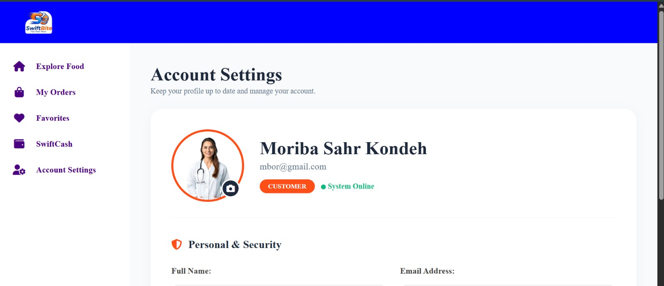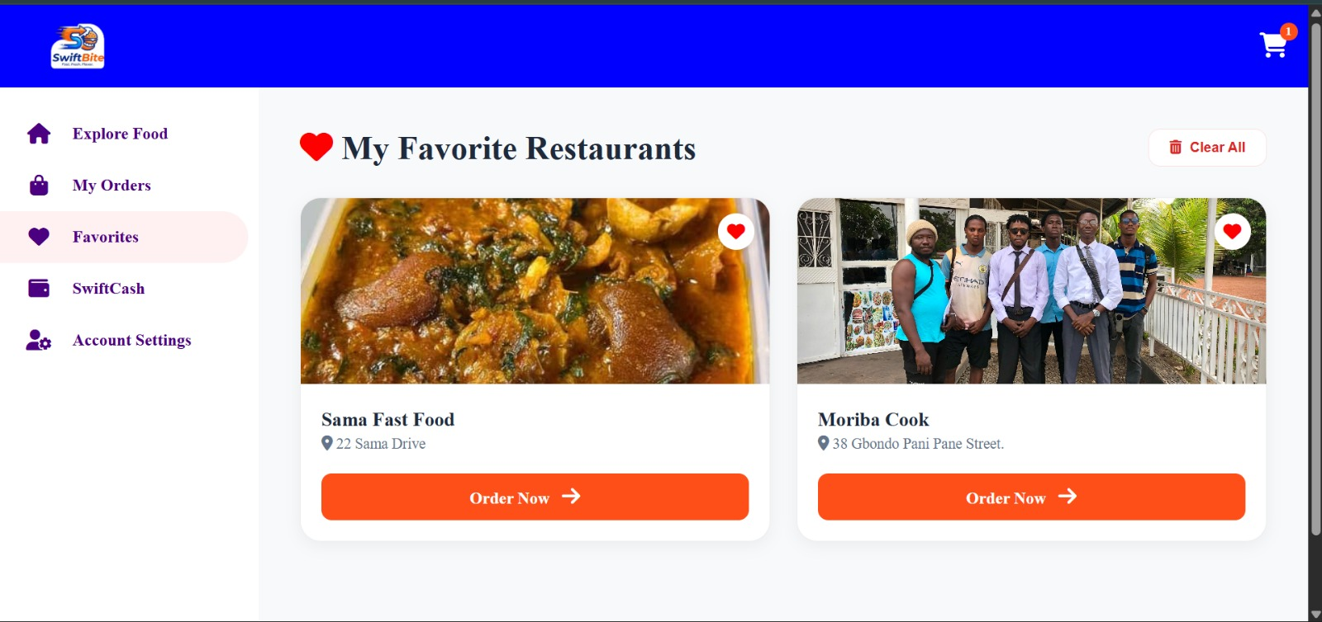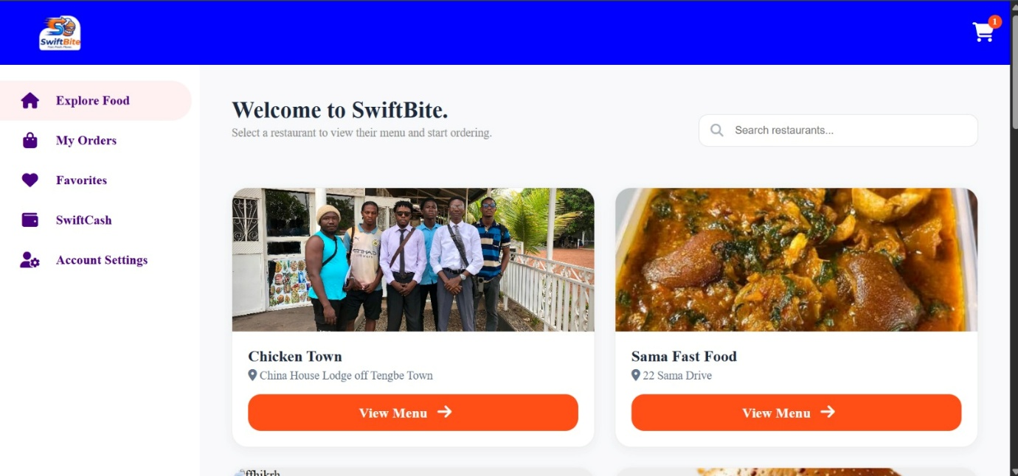
EXPLANATION
The customer page shown is an Account Settings page for a user named Moriba Sahr Kondeh. Here’s a breakdown of what you see:

1. Navigation menu (left sidebar):
- Explore Food: likely a link to browse food items or menus.
- My Orders: view past or current orders.
- Favorites: saved preferred items or restaurants.
- SwiftCash: a wallet or payment feature.
- Account Settings: the current page for managing profile details.

2. Account Settings section:
- Displays the user’s profile photo (a female doctor in a white coat).
- Shows the full name Moriba Sahr Kondeh and email mbor@gmail.com.
- Indicates the user role as CUSTOMER with a green “System Online” status, meaning the system is active.
- Includes a camera icon next to the photo, allowing the user to update their profile picture.

3. Personal & Security area:
- Provides fields to manage personal information such as Full Name and Email Address, suggesting the user can edit these details for profile updates or security purposes.

In short, this page lets the customer manage their personal account information, update their profile, and access other features like orders or payments on the SwiftBite platform.
The page is a customer “My Favorite Restaurants” page on the SwiftBite food‑ordering app.

- Left sidebar contains navigation options: Explore Food, My Orders, Favorites (currently active), SwiftCash, and Account Settings.
- Main section shows a list of the user’s favorite restaurants:
1. Sama Fast Food – displays a food image, address “22 Sama Drive”, and an “Order Now” button.
2. Moriba Cook – shows a restaurant photo, address “38 Gbondo Pani Pane Street”, and an “Order Now” button.
- Top right has a “Clear All” button to remove all favorites, and a shopping‑cart icon with a notification “1”.

The layout lets the user quickly view saved eateries, see their locations, and place orders directly from the favorites screen.
The page you’re looking at is a customer homepage for the food‑ordering platform SwiftBite. Here’s a breakdown of what you see:

1. Top banner: The blue header contains the SwiftBite logo on the left and a shopping‑cart icon (with a “1” badge) on the right, indicating there’s one item in the cart.

2. Left sidebar: A navigation menu with purple icons and text that lets users move to:
- Explore Food: browse restaurants and menus.
- My Orders: view past and current orders.
- Favorites: saved restaurants or dishes.
- SwiftCash: likely a wallet or payment feature.
- Account Settings: manage personal profile and preferences.

3. Main content area: A welcome message invites users to “Select a restaurant to view their menu and start ordering.”
- Search bar: lets users type a restaurant name to find specific places.
- Restaurant cards: two featured restaurants are shown with:
- An image (left: a group photo outside “Chicken Town”; right: a food dish for “Sama Fast Food”).
- Restaurant name and address.
- An orange “View Menu” button to open the menu and place an order.

In short, this page is the user’s entry point for browsing restaurants, managing orders, and accessing account features on the SwiftBite service.
STAFF PAGE
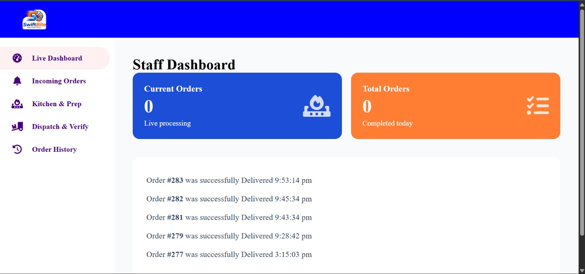

IMPLEMENTATION CODE
code:
app.get("/dashboard", async (req, res) => {
if (!req.isAuthenticated()) return res.redirect("/login");

const { role, tableType, id } = req.user;

if (tableType === "staff") {
return res.redirect("/staff/dashboard");
}

if (!role) return res.redirect("/choose-role");

const routes = {
admin: "/admin/dashboard",
manager: "/manager/menuManagement",
customer: "/customer/home",
};

res.redirect(routes[role.toLowerCase()] || "/choose-role");
});
EXPLAINATION
The page is a Staff Dashboard for a restaurant or food‑service management system called SwiftBite. It’s split into two main sections: a left‑side navigation menu and a central display area that shows order‑tracking information.

Left Navigation Menu
1. Live Dashboard – the active screen you’re on (the staff dashboard).
2. Incoming Orders – link to view new orders arriving in real time.
3. Kitchen & Prep – section for managing food preparation tasks.
4. Dispatch & Verify – area for handling order dispatch and confirmation.
5. Order History – access to past order records.

Central Dashboard
1. Staff Dashboard title – indicates this is the staff operations screen.
2. Two main status boxes:
- Current Orders: shows the number of orders being processed live (currently 0).
- Total Orders: displays the total number of orders completed today (currently 0).
3. Order history log: a list of recently delivered orders with details:
- Order #283 – delivered at 9:53:14 pm.
- Order #282 – delivered at 9:45:34 pm.
- Order #281 – delivered at 9:43:34 pm.
- Order #279 – delivered at 9:28:42 pm.
- Order #277 – delivered at 3:15:03 pm.

Purpose
The dashboard lets staff monitor live order flow, check processing status, and review recent deliveries, helping manage kitchen operations and ensure efficient service.

